**To upload your application on Google Play Store you require:**

1. Android application project in Eclipse or an already created signed ‘.apk’ file of the project that you want to upload on Google Play Store.
2. Internet connection
3. Credit/Debit card to pay for Google Developer license
4. Screenshots and/or videos of your application on your computer (At least two Screenshots are compulsory) If you have an Android application Project in Eclipse then follow the steps given below to generate signed apt. If you already have signed ‘.apk’ file, you may directly start from [Step 10](http://www.theappguruz.com/blog/upload-application-google-play-store#step10)

**Step 1 Open Eclipse**

Open Eclipse with the workspace containing the application project that you want to upload on Google Play Store.

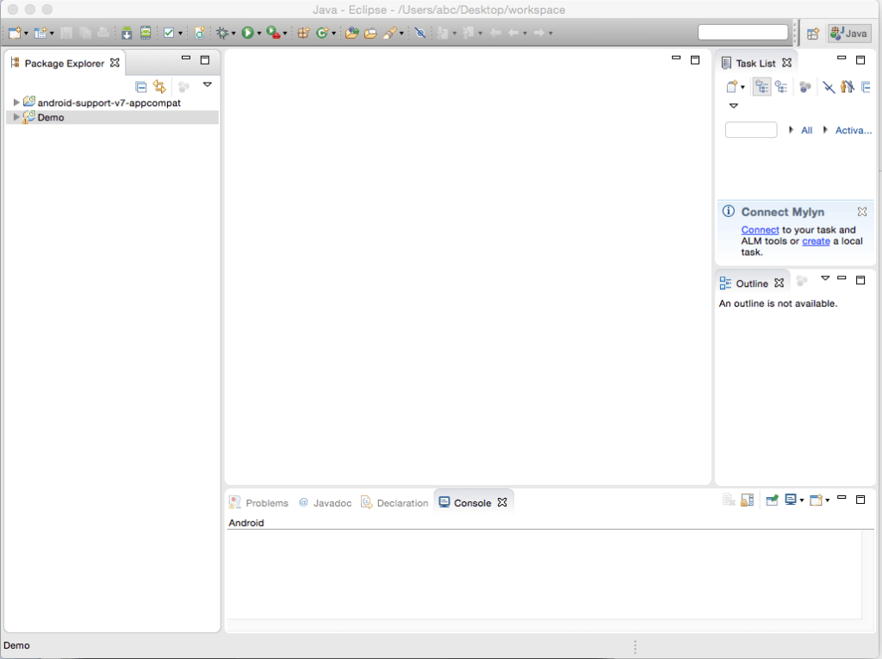

**Step 2 Select Export**

Right click on your project and select **Export**. After you select Export, a dialog box will appear as shown below.

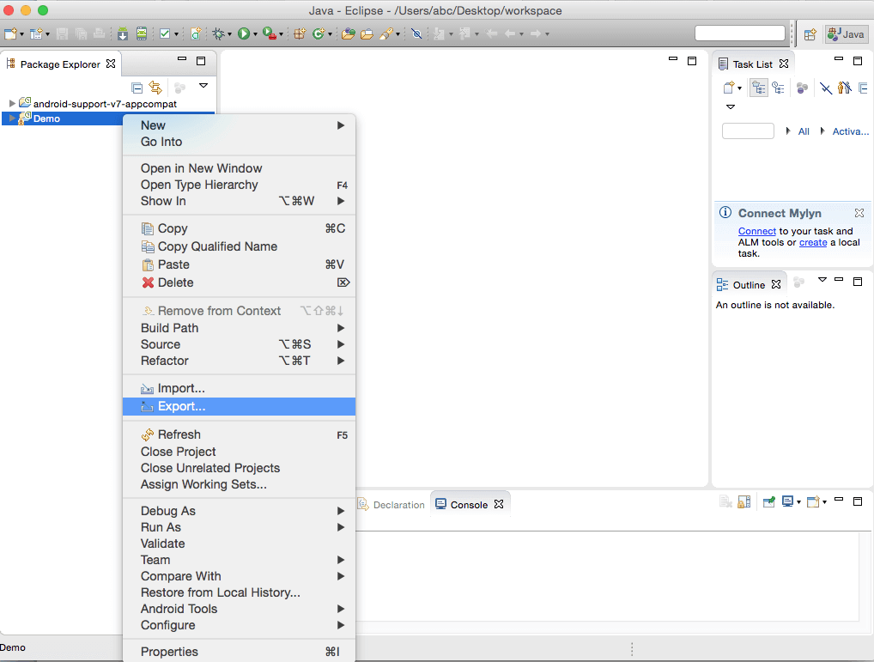

**Step 3 Select export type**

Open the folder titled **Android** and select **Export Android Application**. Then click next. A dialog box labeled **Export Android Application** will appear replacing the old one.

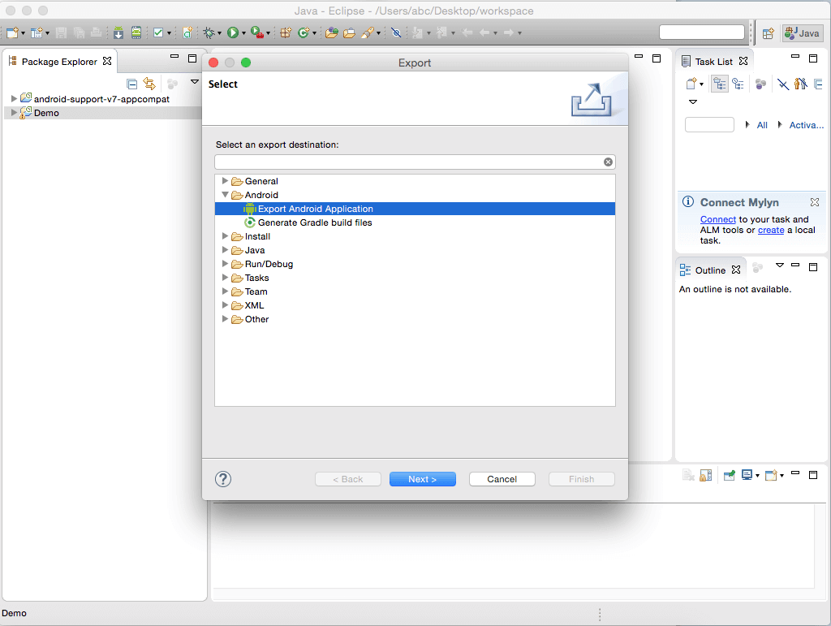

**Step 4 Checking for Errors**

The **Export Android Application** dialog box will check for errors in your project. If your project is error free, the message No errors found. Click next. will appear. Click 'Next', if the project is error free.

**Note**

If your project contains errors, you need to fix them up first and then start with the exporting process again.

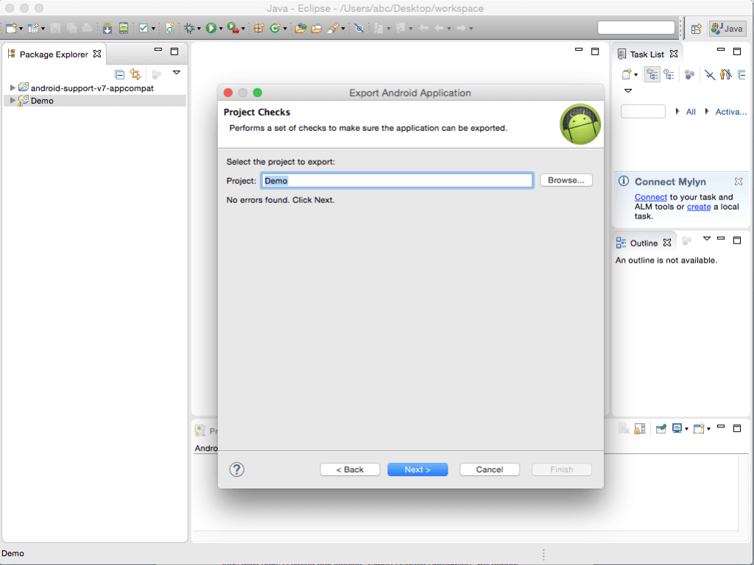

**Step 5 Entering a Keystore**

The next screen that you will see is about entering a **keystore** (Keystore is a type of account that encrypts a stamp onto the final application file). If you have not created a keystore, create it by selecting the radio button for **Create new keystore**.

**Note**

If you have created a keystore previously, enter the name and password and go to [Step 8](http://www.theappguruz.com/blog/upload-application-google-play-store#step8).

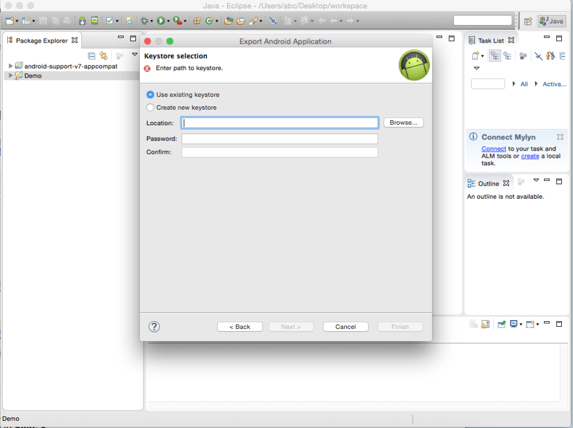

**Step 6 Creating a new keystore**

Click on **browse** button and select a location to store your new keystore file. Preferably keystore can be saved in the same directory where you have your project files. Give a name and select **save**.

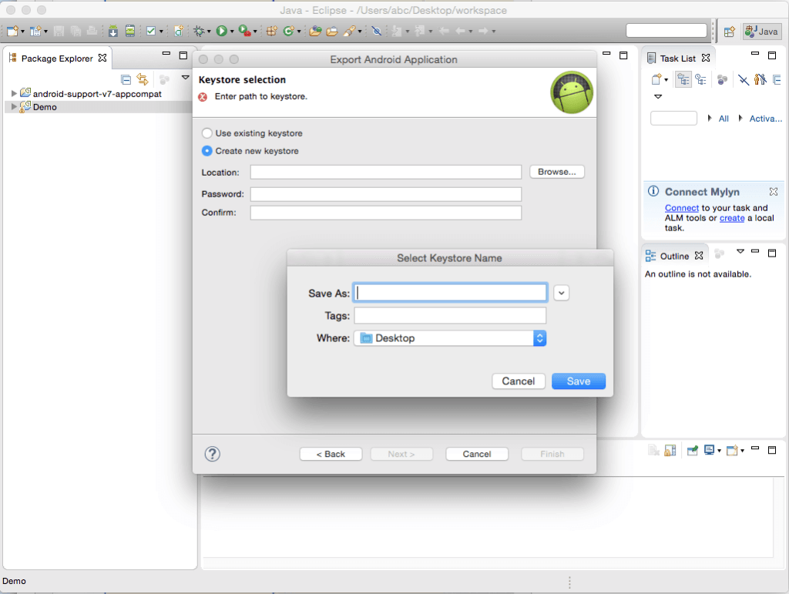

**Step 7 Choosing a Password**

Now, choose and enter an appropriate password (Remember it...!) in both the fields as shown.

**Note**

If you lose your keystore password, you will not be able to release an update for your application in future.

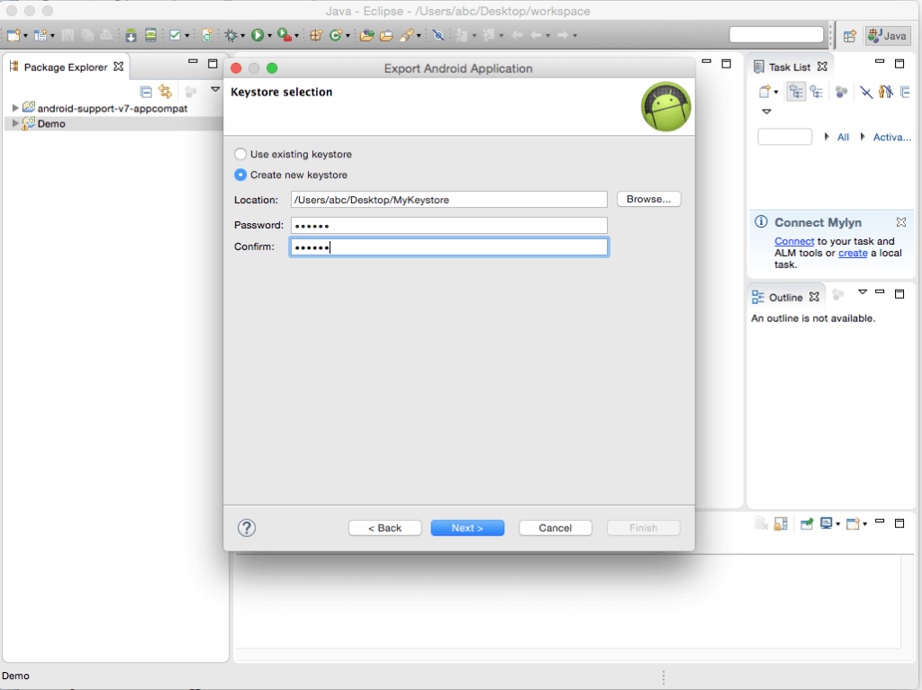

**Step 8 Choosing an Alias**

Now you need to fill alias, password and validity fields on the **Key Encryption** screen. You also need to fill at least one field from **certificate issuer** section. It’s a good idea to use your name for the alias, because it is easy to remember and will never be displayed. Again, choose a password that you can remember.

The number that you choose to enter in the validity field will be the number of years for which your app is available on Google store.

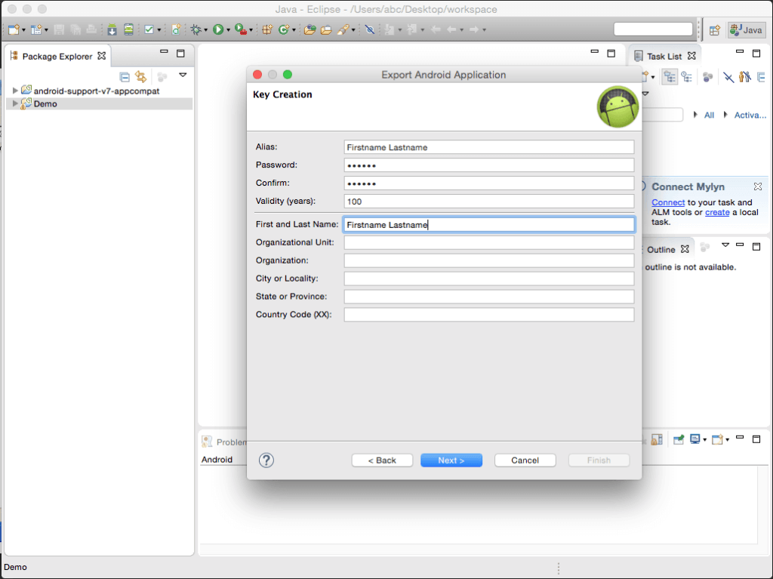

**Step 9 Choose File Export Destination**

The last step in exporting your application is to click on browse and select a destination to store **.apk** (android application package) of your project. Click on **finish** to export the file and then exit eclipse.

**Given below are the steps to upload your .apk file on Google Play Store:**

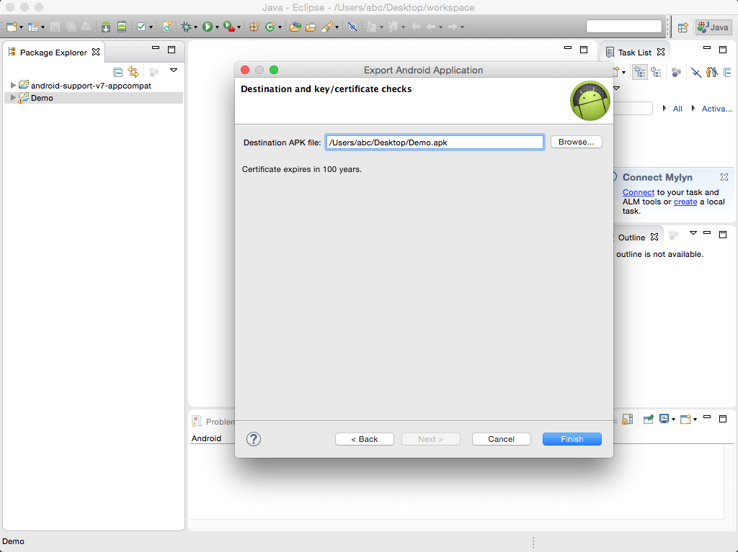

**Step 10 Go to Google Developer Site**

Open browser and search for **Developer Console - Google Play** and navigate to the same.

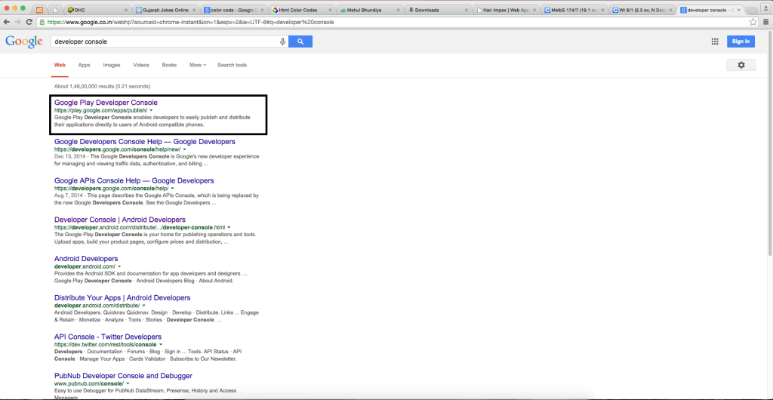

**Step 11 Logging into Google Developer**

Login, if you already have a Google’s developer account.

If you don’t have an account, follow the steps given below to create one. Click on **Sign Up** in the top right hand corner of the screen and follow the rest of the steps. In the last step, you need to pay **$25(one-time) for creating the account by credit/debit card**.

**Console:**

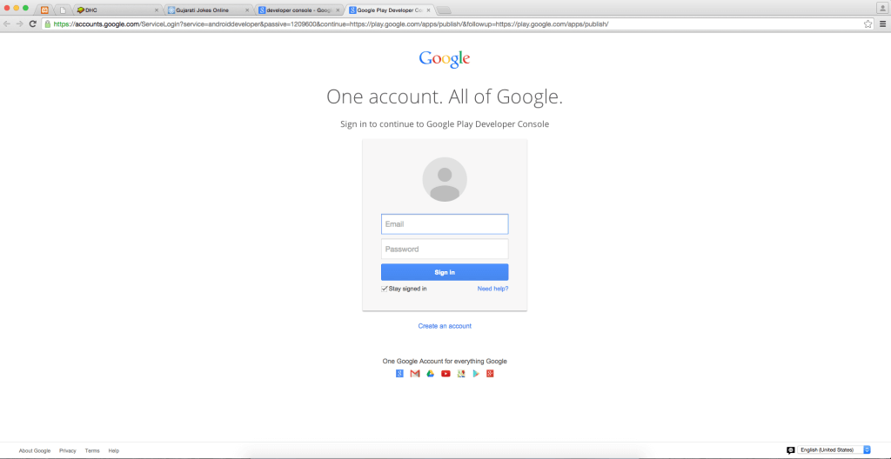

**Step 12 Adding a new application**

Click the blue button labeled **+Add New Application** in the console.

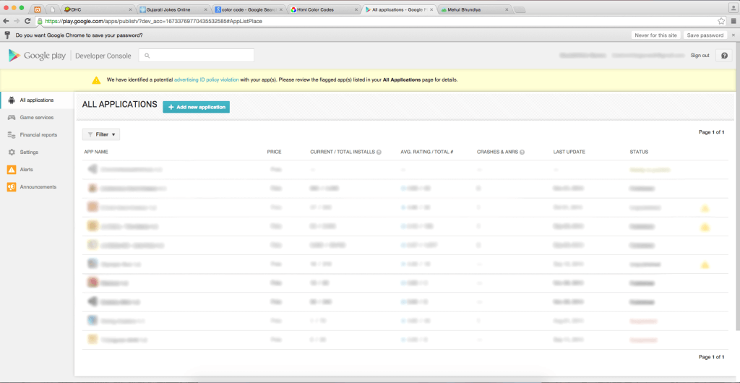

**Step 13 Initiating APK Upload**

In the **Add New Application** dialog box, select the required language from the drop down menu and then type the name of the application as you want it to appear in Google Play Store and select **Upload APK** button.

Now, you will be diverted to a new homepage for your application.

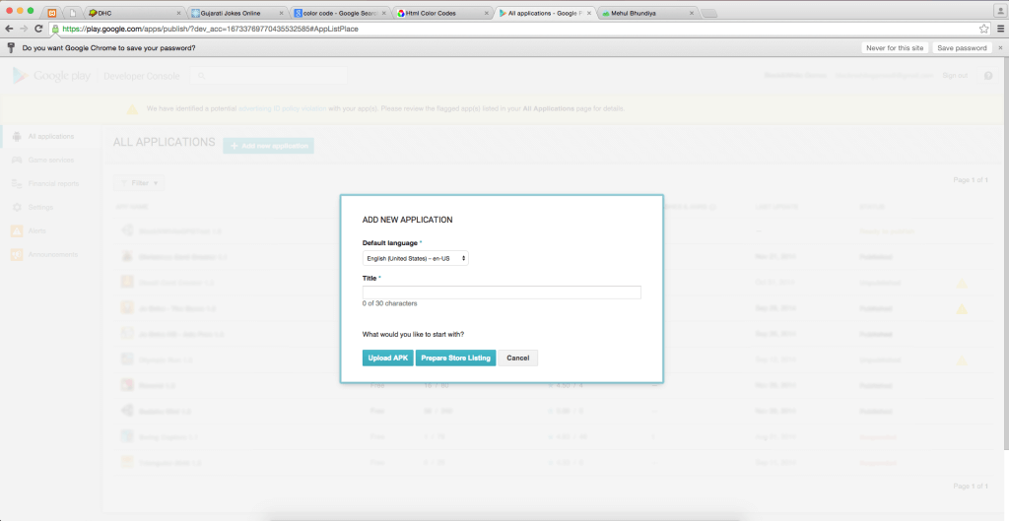

**Step 14 Initiating APK Upload (part-2)**

On the new homepage of your app, select the button labeled **Upload your first APK to Production**.

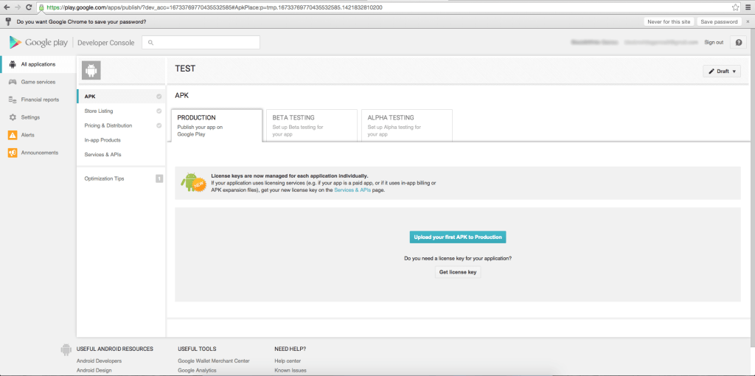

**Step 15 Select and upload APK file**

A dialog box will appear from where you can 'browse' and open your .apk file which you have exported from Eclipse.

**Status of uploading is shown in the progress bar:**

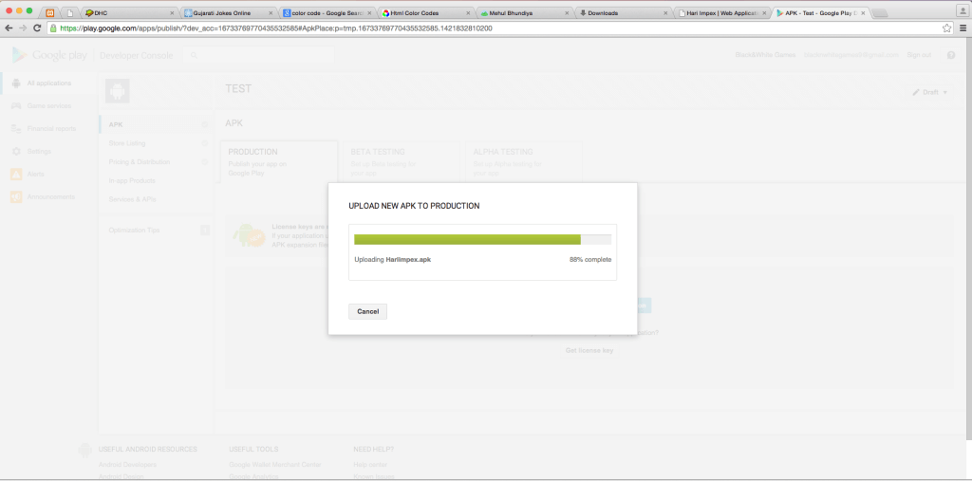

**Step 16 Add description to your project**

After the APK is successfully uploaded, a description needs to be added to the ‘store listing’ page which is found by navigating the tabs on the left.

Type the application description in the **description** text box. This description will appear in the Google Play store on the page for your application.

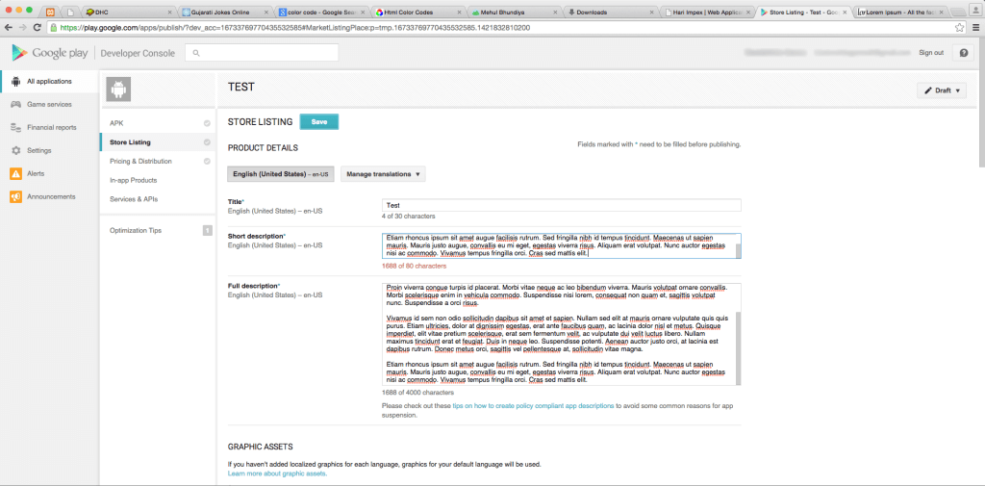

**Step 17 Add Screenshots of your application**

The next step is to add sample screenshots of your application. To upload screenshots, scroll down and click on one of the three **+ Add Screenshot** buttons corresponding to the type of device they were taken on.

A dialog box will appear allowing you to select the screenshots from a directory on your computer.

* 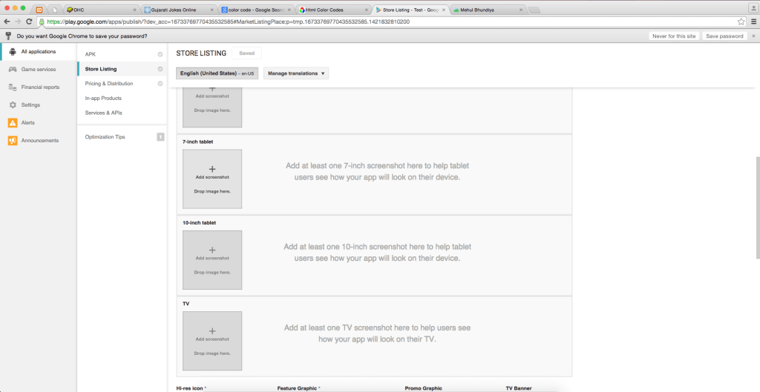
* 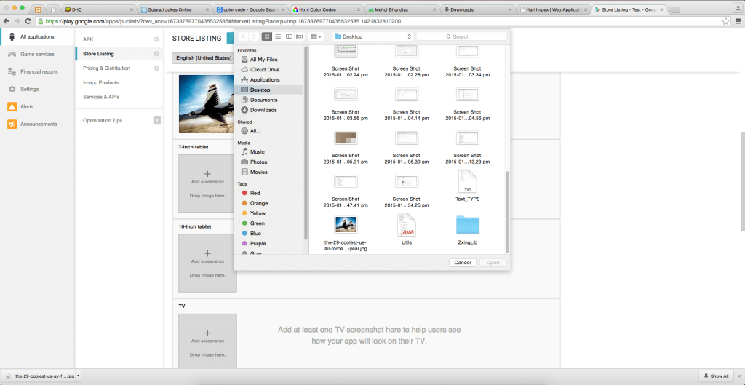

**Step 18 Adding an Icon to your application**

Icon is the main picture that pops up at the top of the screen in the Google Play Store with your application name. Whenever a browse button is clicked, a dialog box will open allowing you to select the icon in the same way as you selected a screenshot in [Step 17](http://www.theappguruz.com/blog/upload-application-google-play-store#step17).

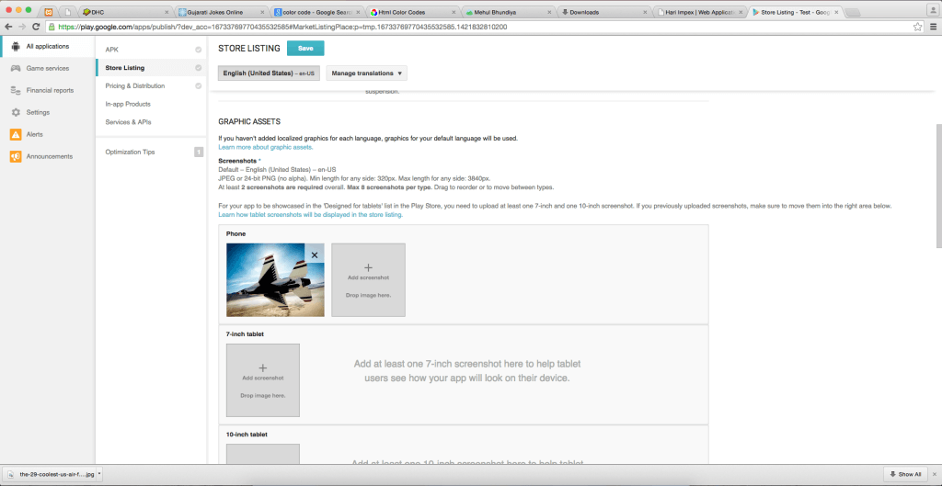

**Step 19 Filling Details**

The final step on the **Store Listing** page is filling out the categorization, contact details, and privacy policy. Fill out the required fields according to your discretion and click on save button. The ‘store listing’ tab should now have a green check-mark next to it.

**Step 20 Pricing and Distribution**

Now click the **Pricing & Distribution** tab, where you will select paid or free, distribution countries, and check the boxes saying that your app complies with the content guidelines and US export laws. Click on **Save** button at the bottom.

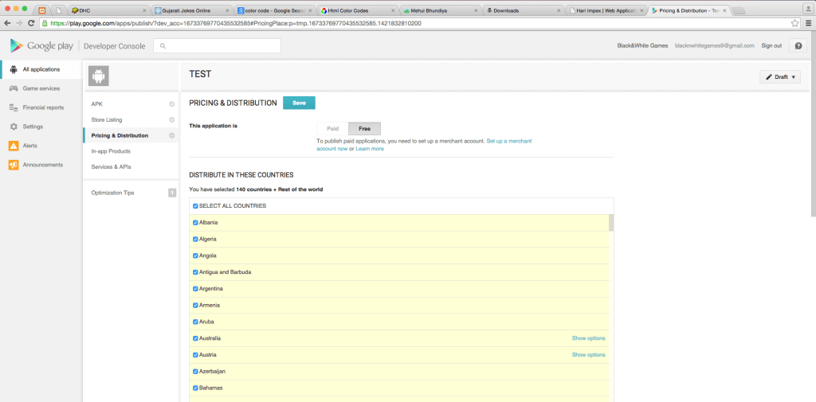

**Step 21 Publishing your application**

Once all the three tabs on the left have a green check-mark, you can select **Publish this app** from the **Ready to Publish** drop-down menu in the top right hand side corner of the developer console.

A confirmation bar will appear at the top, indicating that your app will be available in the Google Play store in just a few hours.

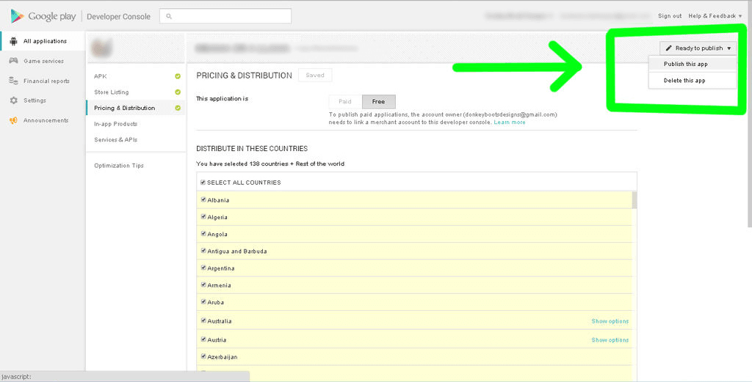

- See more at: http://www.theappguruz.com/blog/upload-application-google-play-store#sthash.Gv5fjP6N.dpuf